Nepal College of Information Technology
Unit Test 2009

Program: CE/ELX Time: 2 hrs
Semester: Spring(II) FM: 60
Subject: Applied Mechanics PM: 30

Attempt all question.
1. The directions of the 300 N forces may vary, but the angle between the forces is always is 45°. Determine the value of α for which the resultant of the forces acting at A is directed vertically upward. [10]
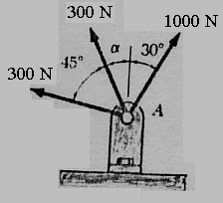

2. Determine the force in each cable needed to support the 500 N bucket. [10]

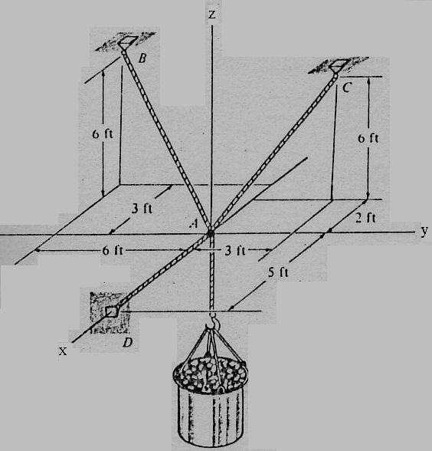

3. A force P of magnitude 2600 N acts on the frame shown at point E. Determine the moment of P about a line joining points O and D. [10]

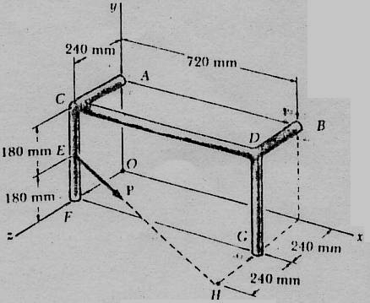

4. Determine the moment of inertia of any half circle by method of integration. [10]
5. Locate the centroid given figure. [10]

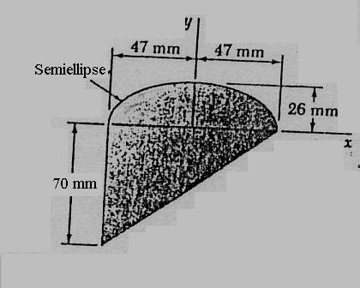

6. Three cables are used to support a container as shown. Determine the angle formed by cable AC and AD. [10]
x
y
450 mm
650 mm
700 mm
z
D
C
B
A
O
600 mm
1125 mm

